# DML Exercise

## Part 1 – Create Table

Create a table in your database named REPAIR that will have six fields as shown in the figure below. Use appropriate field data types and sizes based on the sample data. Don’t worry about constraints at this time.

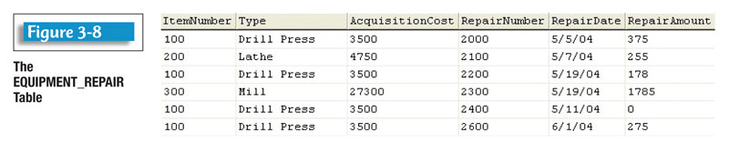

## Part 2 – Insert the Data

Use the INSERT command to populate the table with the sample data. Remember the default Oracle date format.

## Part 3 – Functional Dependencies and New Tables

Looking at the sample data you may have noticed that it is really representing two distinct entities. These entities can be expressed as functional dependencies. The two entities are:

1. Item(**itemNumber**, type, acquisitionCost)
2. ItemRepair(**repairNumber**, repairDate, repairAmount, itemNumber)

Create the two entities as new tables, make sure to create a primary key for each, and a foreign key for ItemRepair on itemNumber.

## Part 4 – Populate with Existing Data

Utilize a select command to pull the data from Repair to populate the two new tables. Note that when populating Item use “SELECT DISTINCT ….. ;” as several of the items repeat throughout the table. DISTINCT will be covered in more detail later in the class. DISTINCT comes before the field list in the select command.

## Part 5 – Commit and Rollback

Commit the changes you’ve made. Use the delete and update commands to make changes to the data. Rollback your changes. Ensure your changes were undone using select to verify the data.